**Router Basics**



Router : Router is a Interconnecting device used to connect two or more different networks . Within the same location or two different geographical locations . 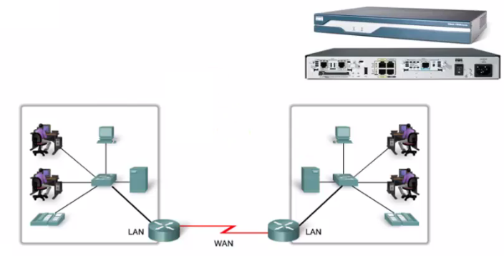

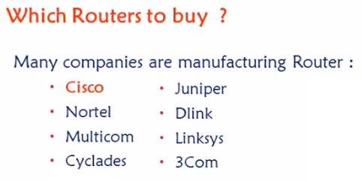

All company routers - Implementation , Features and functionality all will be exactly same , other than the way you configure it , Only CLI configuration will be different.

Cisco develops routers in 3 layer hierarchy .

**Cisco three layer Hierarchy.**

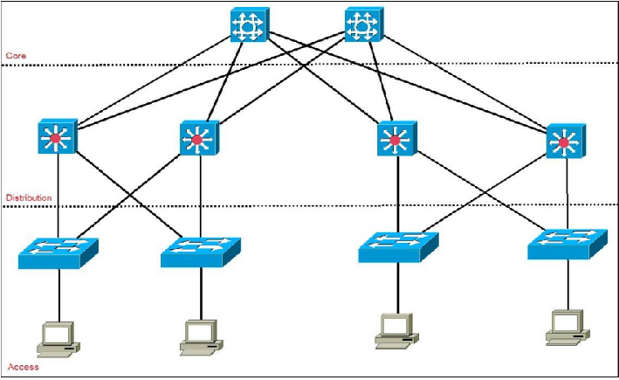



1.Access layer - They are typically low end routers , Low in terms of cost , Processing , and also number of ports .

2.Distribution Layer

3.Core layer– high speed routers

intel celeron processors – P4 - MS office and internet

i3 i5 i7 processors – Java and programming languages

intel xeon itanium processors – High speed processors – Server based applications

Communication between networks connected to edge routers will have less traffic ,

communication between two different networks’ between two core layer routers will have more traffic .

**Switches**

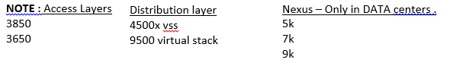



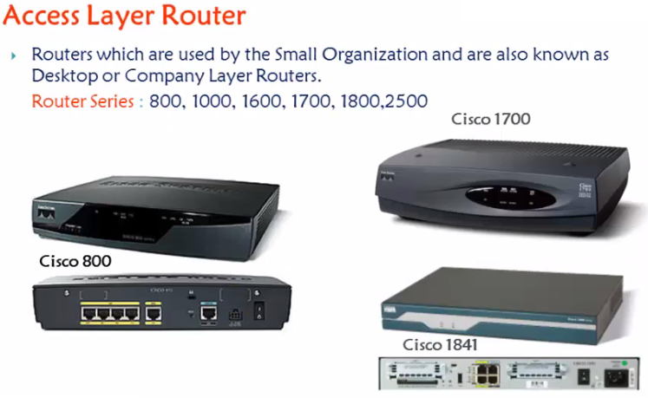



Dist Routers : Core layer routers :



2600 , 2800 , 3700 , 3800 . 6400 , 7200 , 8000 , 9000 .



**Router Classification .**



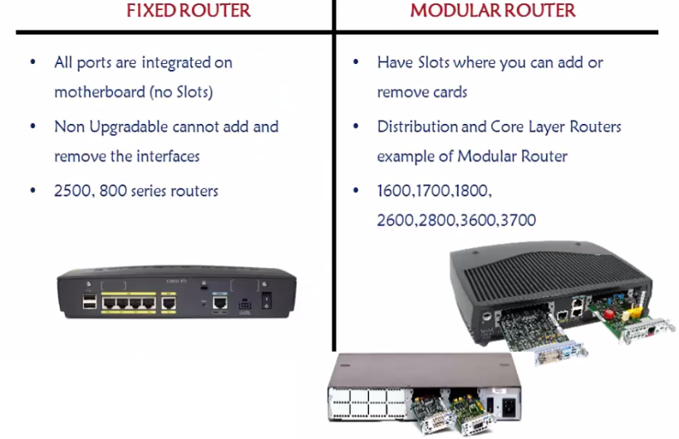



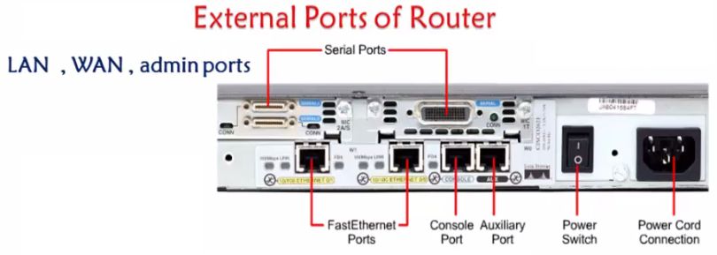



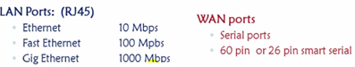



26 Pin serial ports are called smart serial ports

Admin ports carry commands , Not traffic .

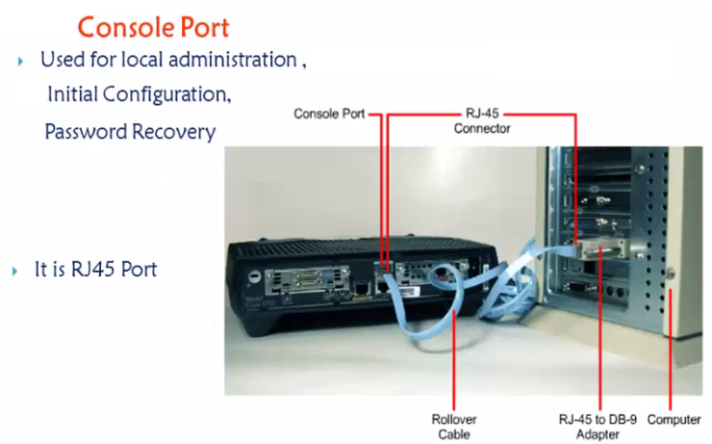

Putty terminal software . / HyperTerminal .

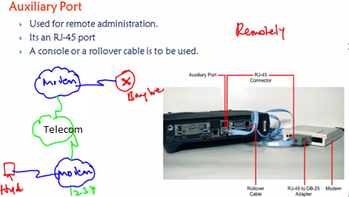

AUX port is used to access the device remotely through dail – Up modem . But disadvantages are

Auxiliary port disadvantages .

1.No reliable

2. Does not support high speed

There is one more way to access the device remotely – telnet / SSH

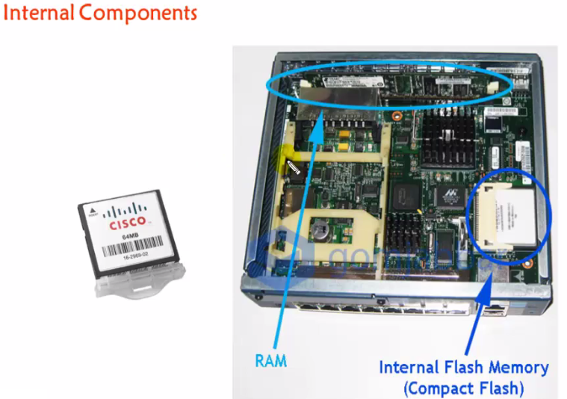

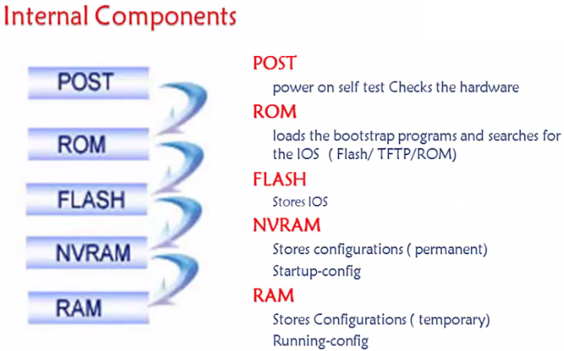



Booting Process .

POST , ROM , Flash , NVRAM , RAM – Setup mode ,

**Cisco Router Modes .**

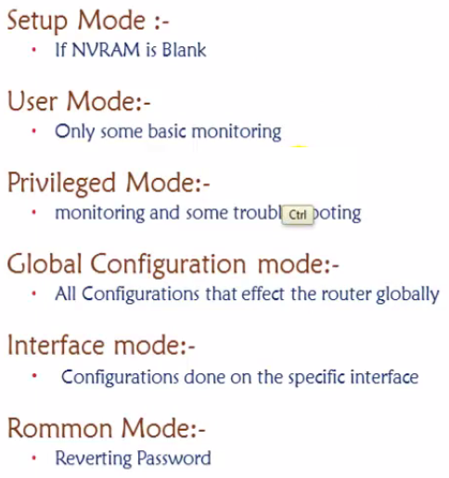

**User mode** : Basic Ping , Basic Trace , Basic show commands .

**Previlege mode** : If you want to do complete monitoring , Complete show commands then PM .

100 per commands only show .

**Global conf mode** : Any changes then Global config mode .

1. Basic configuration 2. Router CLI modes 3. Configure Password(Secret,Telnet, Console) 4. Configure hostname & login banner 5. Encrypt password

Setting up passwords .

Enable password / Enable secret

Console password .

Telnet Password .

Save and remove all configurations .

Router#**erase startup-config**

Router#**reload**

Password recovery .

This is done when routers kept on store are taken for new implementation , or old admin didn’t save the password correctly or incorrect password . Then we will not be able to access the router so we need to make some password recovery mechanisms .

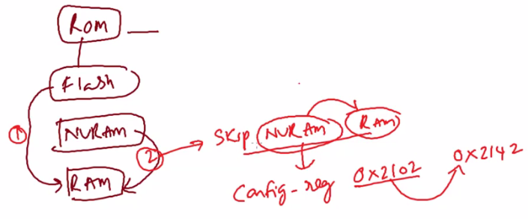

Show version – default is 2102 .

Ctr + PauseBreak / Ctr + shift + Pausebreak

ROMMON> Confreg 2142

ROMMON> Reset

**How to assign ip address to a Router Interface**

**####################LAB commands START##############**

**Lab Manual 1**

**NETWORK ESSENTIALS LAB Manual**

**User mode** : Basic Ping , Basic Trace , Basic show commands .

**Privilege Mode** : If you want to do complete monitoring , Complete show commands then PM .

100 per commands only show .

**Global Configuration mode** : Any changes then Global config mode .

**Basic configuration – Hostname, Clock, no ip domain lookup. Setting up History size**

R1(config)#hostname R1

R1#clock set 10:10:10 march 10 2020

R1(config)#no ip domain-lookup

R1#terminal history size ?

<0-256> Size of history buffer

**Configure login banner**

R1(config)#banner motd $ ALERT - HEADOFFICE ROUTE$

**Configure Password(Enable,Console,Telnet)**

R1(config)#enable password cisco

**Encrypt password**

R1(config)#service password-encryption

R1(config)#enable secret cisco123

**Save all configurations** .

R1#copy running-config startup-config

Destination filename [startup-config]?

Building configuration...

[OK]

**Remove all configurations**

Router#**erase startup-config**

**Restart Router and switch**

Router#**reload**

R1(config)#line con 0

R1(config-line)#password cisco

R1(config-line)#login

R1(config-line)#exi

**TELNET – Pre requisites**

1.Connectivity

2.Enable password

Then configure telnet with below commands

R1(config)#line vty 0

R1(config-line)#password cisco

R1(config-line)#login

R1(config-line)#exi

R1(config)#username AAA password AAA

R1(config)#line vty 0 4

R1(config-line)#login local

R1(config-line)#exi

**Password recovery** – for routers

Physical OFF and ON

CTR+SHIFT+PAUSE/BREAK (Pause/Break or equivalent command depends upon diff laptops)

Self decompressing the image : #################################

monitor: command "boot" aborted due to user interruptp

rommon 1 > confreg 2142

rommon 2 > reset

Continue with configuration dialog? [yes/no]:no

Router>enab

Router#conf t

Router(config)#no enable password

Router(config)#no enable secret

Router#show version

Configuration register is 0x2142

Router(config)#config-register 2102

Router#reload

This time it will not ask for the password.

**How to assign IP address to the interface of the Router**

R1(config)#interface fastEthernet 0/0

R1(config-if)#ip address 10.0.0.1 255.0.0.0

R1(config-if)#no shutdown

R1(config-if)#exi

**##########################LAB END ######################**

**SWITCHING**

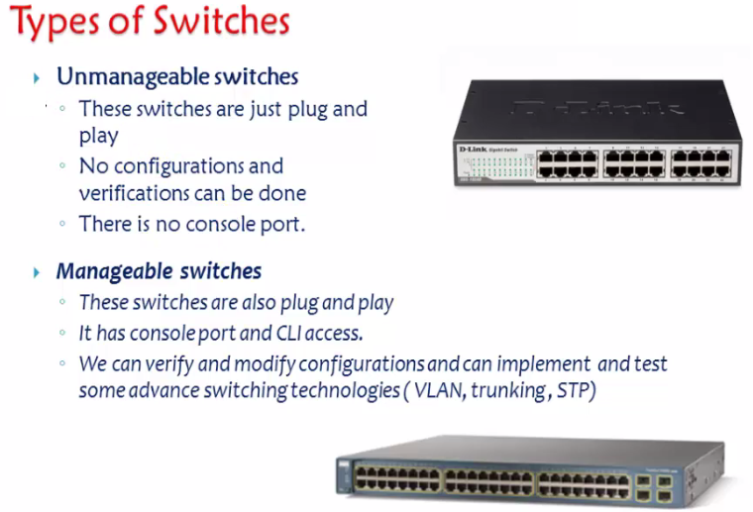

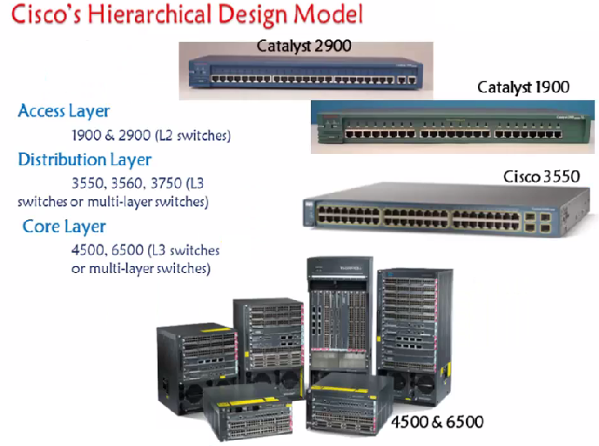

Difference between Router and L3 switch .

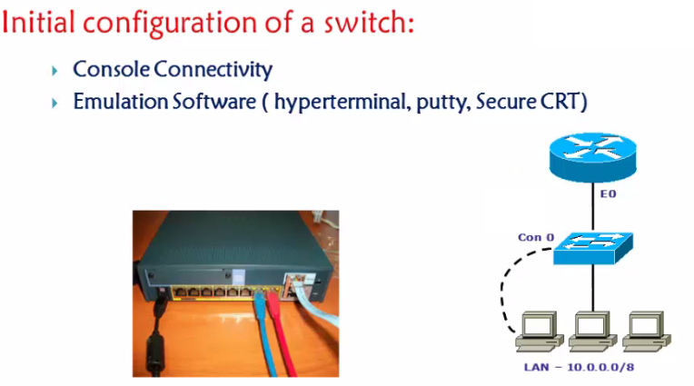

DB 9 connector or 9 Pin connector.

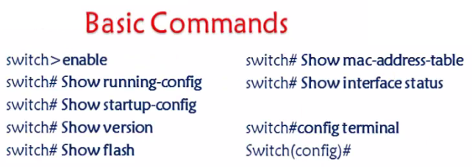

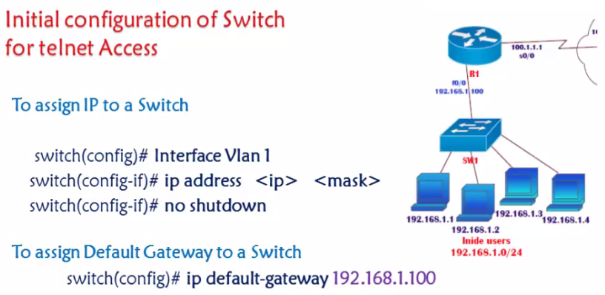

Only Reason we provide a IP address to a switch is to access that switch . Telnet access .

There are 3 conditions to access any device

1.Connectivity

2.IP address Configured on that device

3.There should be a VTY password configured .

**Lab: Requirement here is , I need to access the switch from the computer 192.168.1.1**

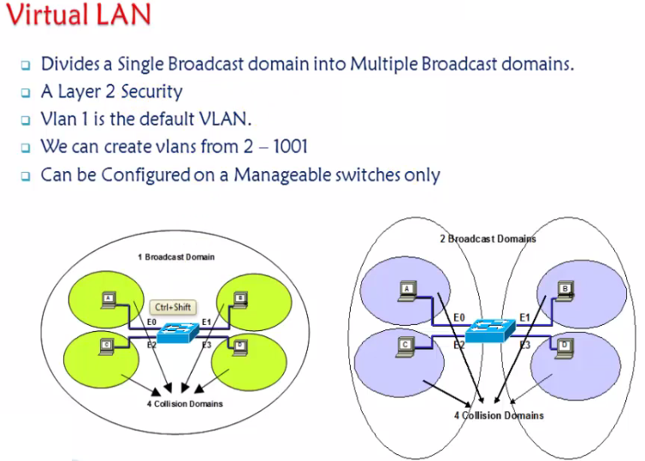

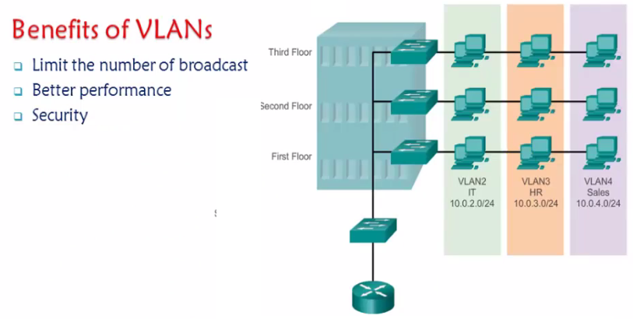

Types of Vlans

1.Static Vlan - Based on port numbers

2.Dynamic Vlan – Based on Mac address .

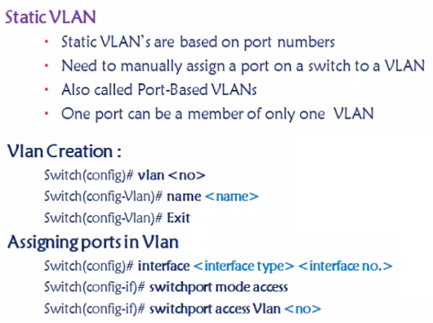

**Lab Task : Create 4 vlans [Vlan 10 , 20 , 30 , 40]**

**Assign port 10 to Vlan 10 , Port 2 – 5 and port 8 to vlan 20**

. 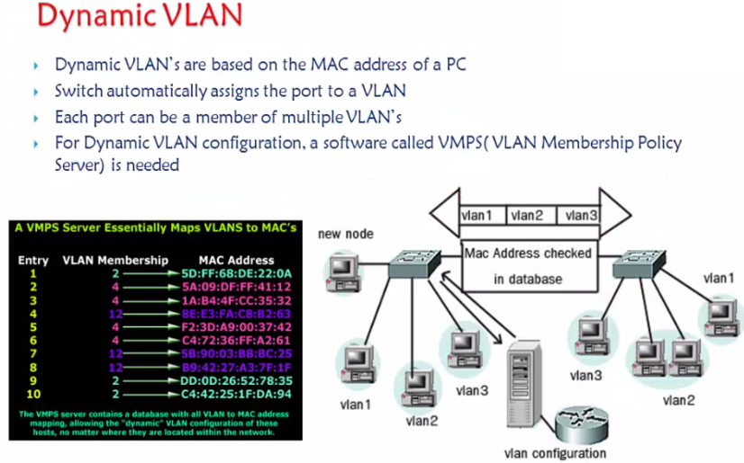

**Trunk**

A **trunk port** is a **port** that is assigned to carry traffic for all the VLANs that are accessible by a specific switch, a process known as trunking.

Note : Show Real time Drawing

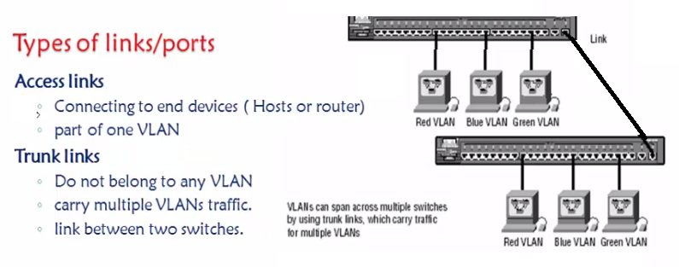

When multiple frames from different vlans are passing through the trunk how does the differentiation happens – Through Frame tagging . Who maes these tagging ?

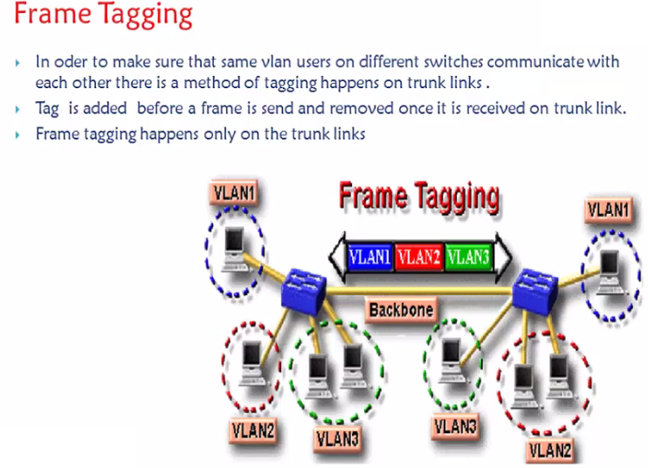

Adds tag and removes tag – at both ends of the trunk .

These tagging process is done by two protocols .

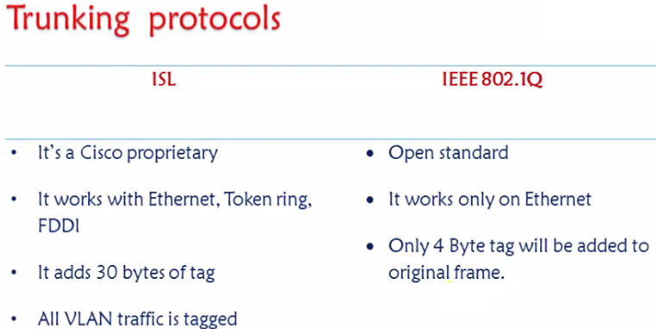

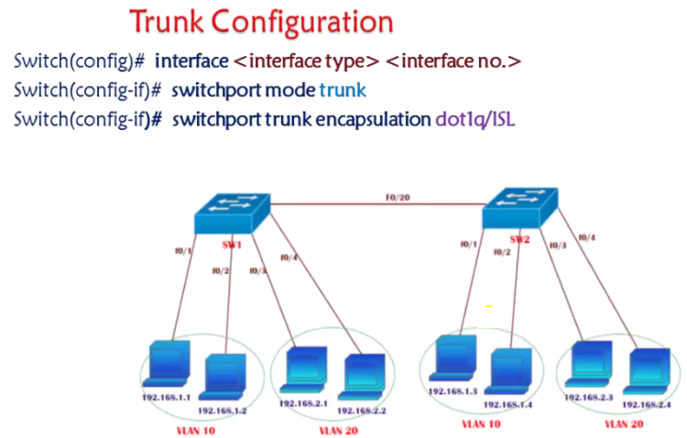

LAB : Perform Lab for Trunking . Also show it through simulator in Packet tracer .

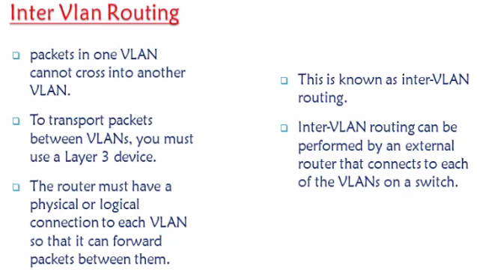

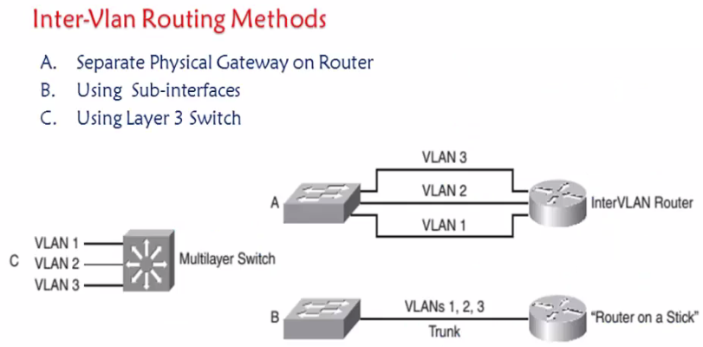

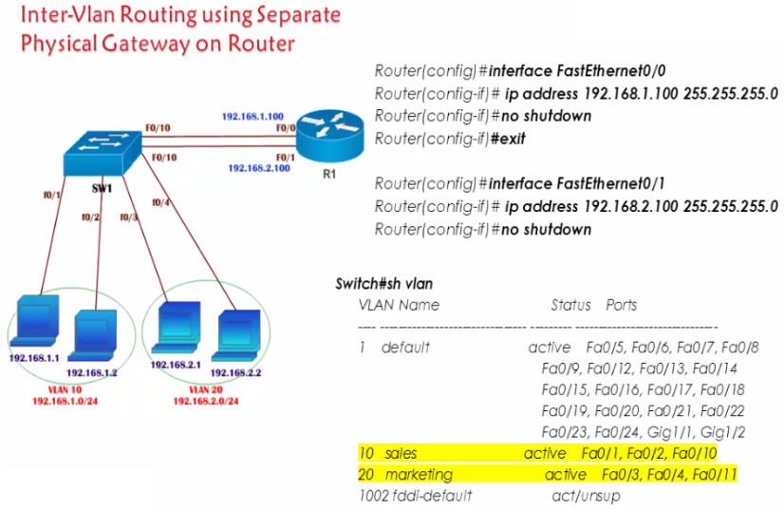

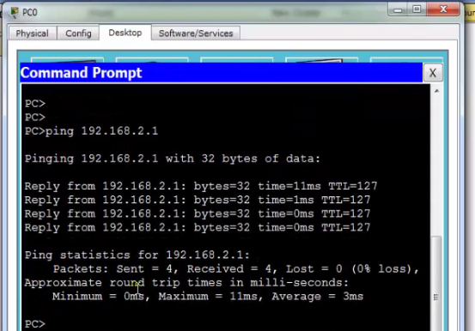

Minimum Maximum and average – Used to check Latency in real time

show tracert and traceroute .

Disadvantages in 1 st method is , for communication we need 2 separate cables as DG for 10 Vlans 10 cables cannot be used , Hence Router on a stick was found .

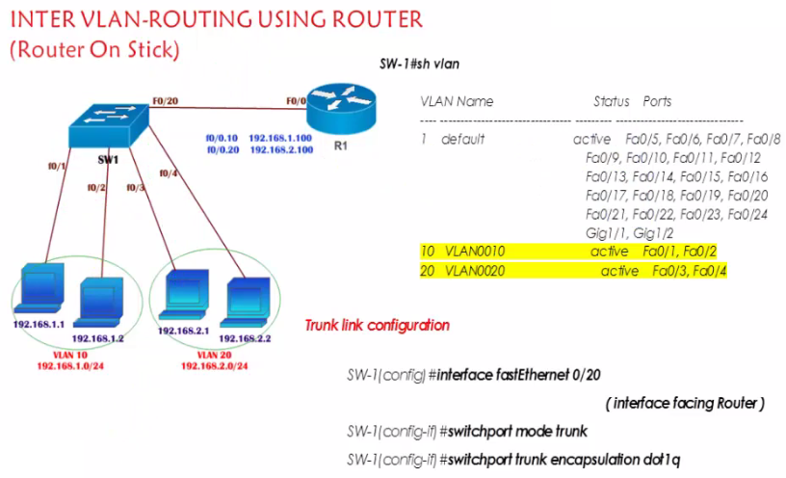

Router configuration .

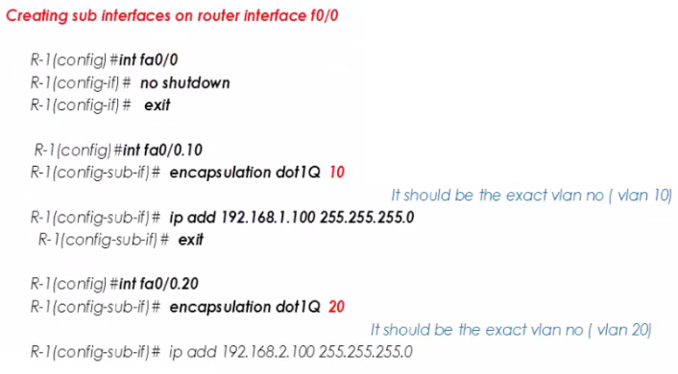

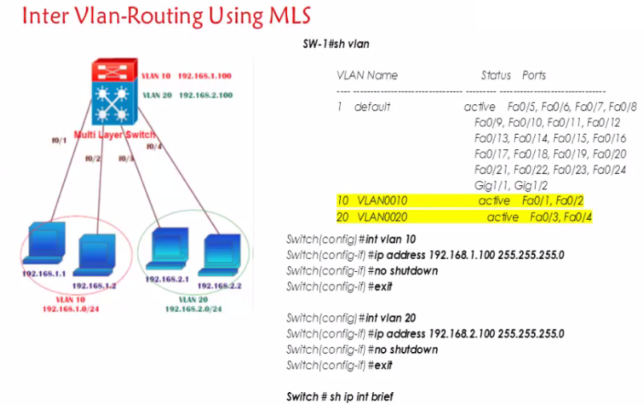

“IP ROUTING” – Important .

So here we using something called SVI Switch Virtual Interface similar to DG for each Vlan .

Extended Vlan

Voice Vlan

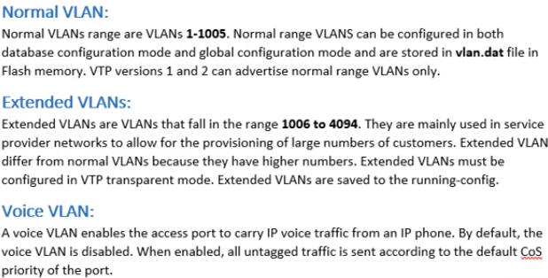

NOTE: Extended Vlan are store in Running configuration but normal Vlan is stored in Flash .

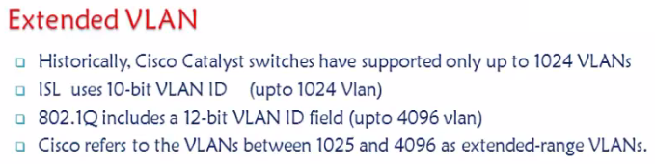

We can create Vlan from 2- 1001 which is called as Ethernet vlans.

1002 – 4096 We call it as Extended Vlan

**NOTE :** For using Extended the Hardware feature should support it first , Then to enable we should use this command “Switch(config)#[**spanning-tree extend system-id**](http://www.cisco.com/en/US/customer/docs/switches/metro/me6500/software/12.2_18_ZU/command/reference/S1.html#wp1045783)” , Meaning we should enable the extend system-id feature only then we can create Extended Vlan

**NOTE :** Catalyst was a company which produced switches and which was bought by Cisco. Cisco has sold that series of switches formerly sold by that company named catalyst as catalyst switches. Nowadays, Cisco has also some switches, that are develoed by Cisco itself, for example Nexus switches. Calalyst switches are switches belonging to that old series of switches and switches developed on the base of those switches (for example catalyst 2960 series, catalyst 4500 series, catalyst 6500 series). For catalyst switches, CatOS and IOS are available (for newer models like 2960 only IOS). Nexus switches have a different architecture. The operating system of Nexus switches is not IOS anymore, it's NXOS.

Basic pre-requsite for Extended vlans .

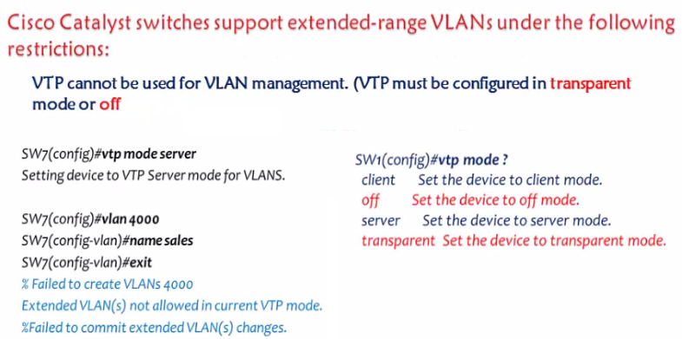

2.

Spanning tree extended ID feature must be enabled , However by default in most of the switches this feature is enabled by default .

“Show spanning ree summary” .

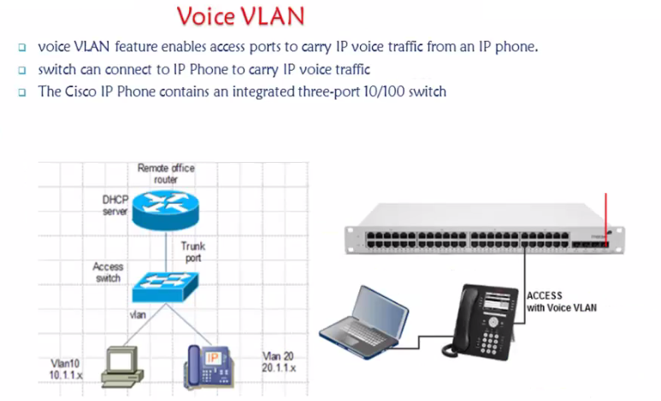

NOTE: Two ports can be a part of two vlans only when it is a Voice vlan ,

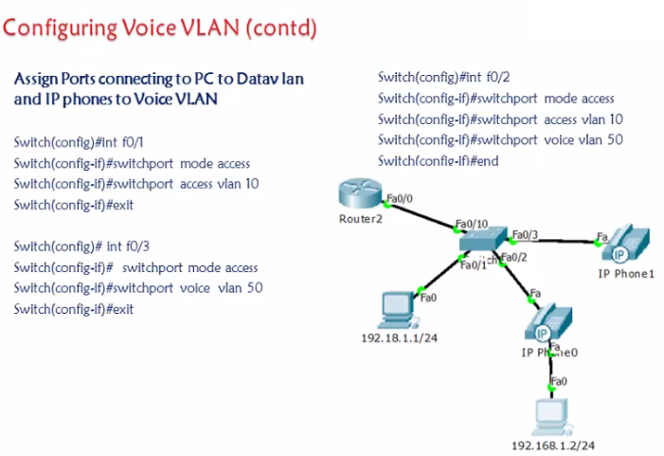

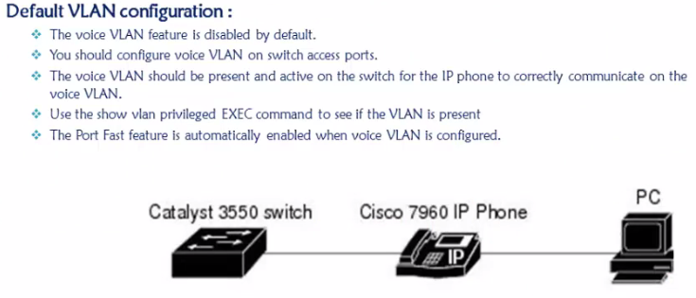

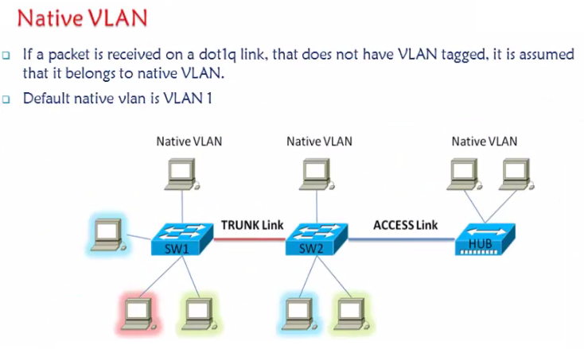

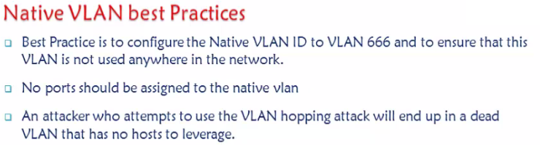

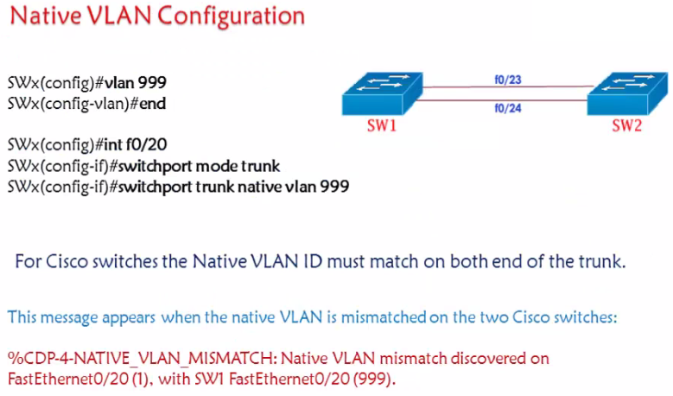

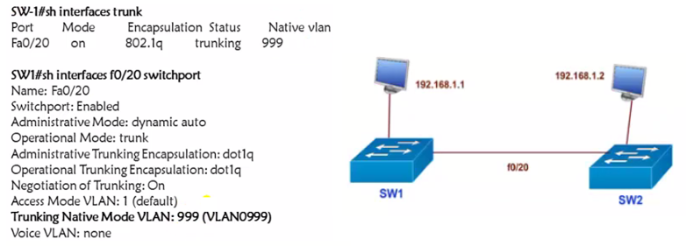

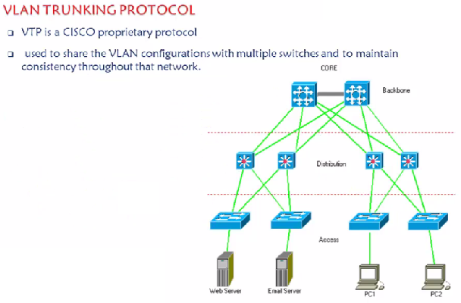

Create , Modify and delete – If we have to do these three things can be done from server switch itself that’s the feature of VTP

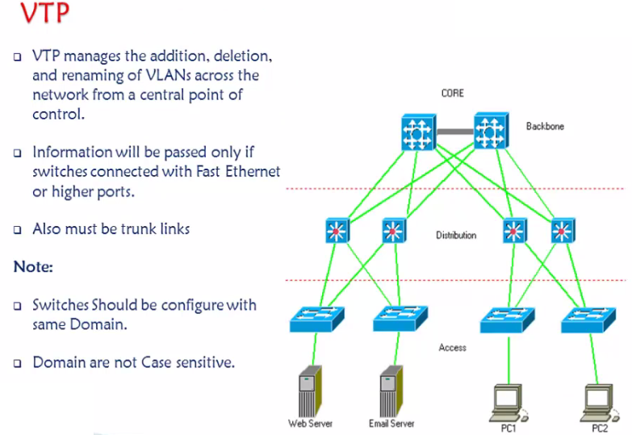

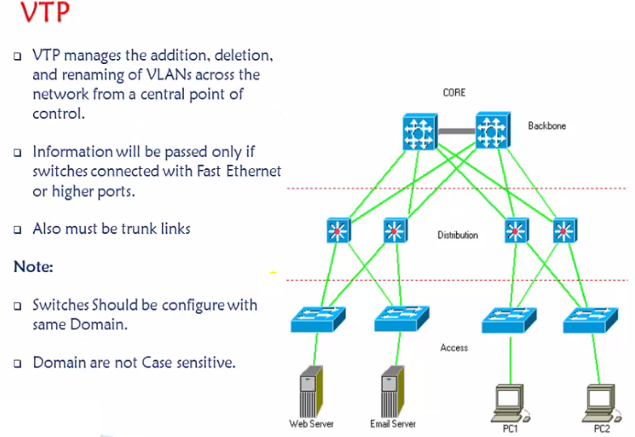

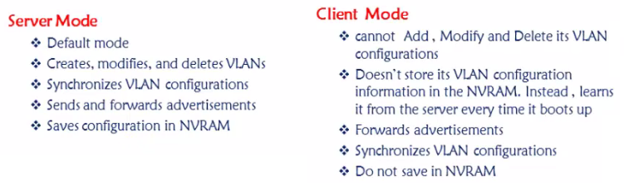

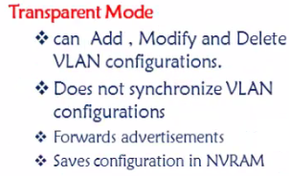

Transparent will not send any information but it will forward the information.

In this lab the pre-requisite is Trunking . Password is Optional ,”VTP domain CCIE” – Will enable VTP , difference between Version 1 and 2 – 2 is much secure than 1 and Token will be added in 2 .

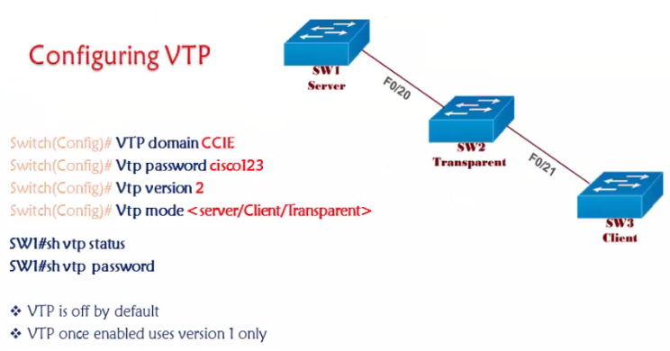

If a switch with a highest revision number is added to the above topology the vlan database will be changed . Question here is what will happen if a new switch with same revision number is added to the above topology .

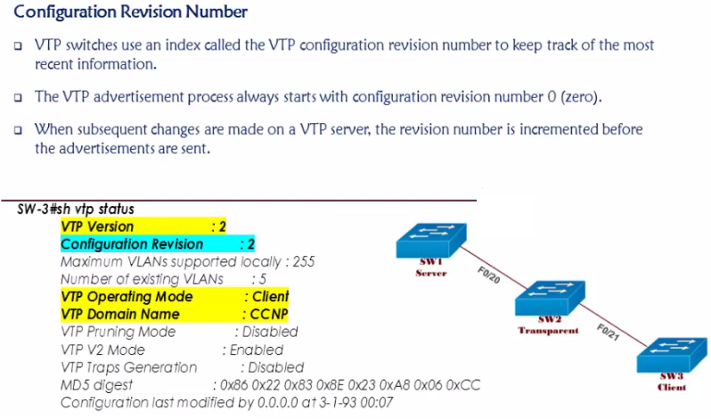

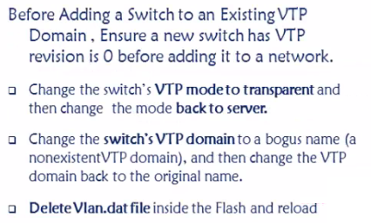

**Spanning tree protocol**

IEEE Standard 802.1D

BPDU – 2 Types

1.Configuration BPDU

2.TCN BPDU

Contents of Configuration BPDU

12 contents in BPDU

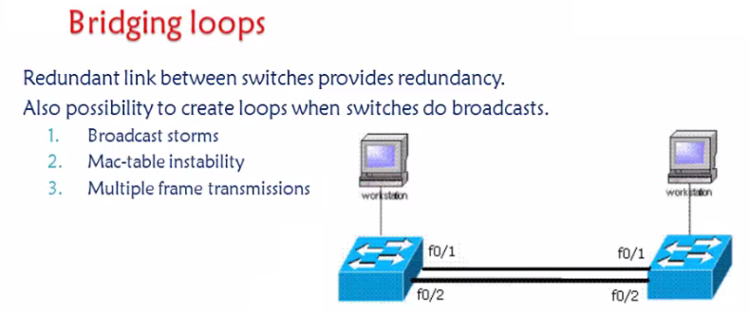

Solution

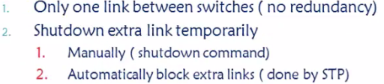

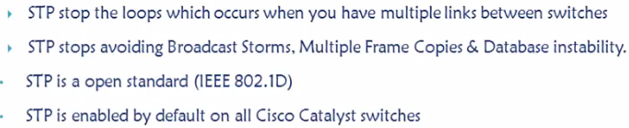

STP was initially found by “digital equipment co-operation” later made as a standard.

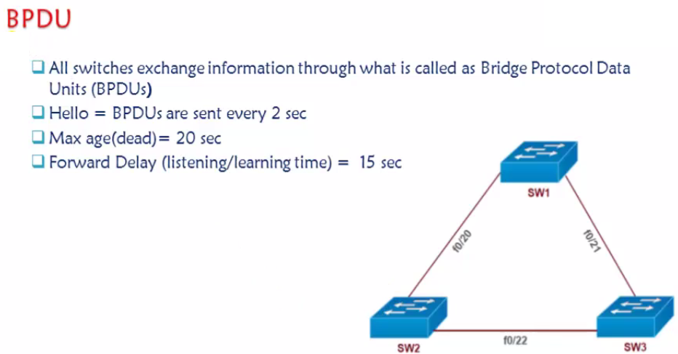

How STP works

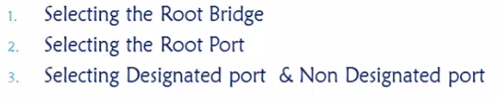

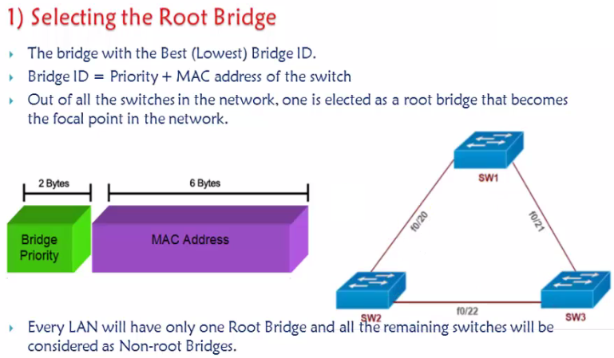

Default Priority – 32768 + Vlan ID . If priority I s same then the tie breaker will be Mac Address .

Show version – Base mac address . Only One root bridge , remaining non root bridges , BPDU will pass bridge ID information with all .

Note: Least is always preferred in Spanning tree .

**************************

SW1(config)#spanning-tree vlan 1 priority 1

% Bridge Priority must be in increments of 4096.

% Allowed values are:

0 4096 8192 12288 16384 20480 24576 28672

32768 36864 40960 45056 49152 53248 57344 61440

SW1(config)#

**********************************

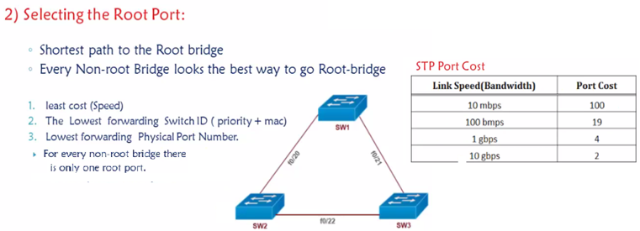

**Spanning tree link cost**

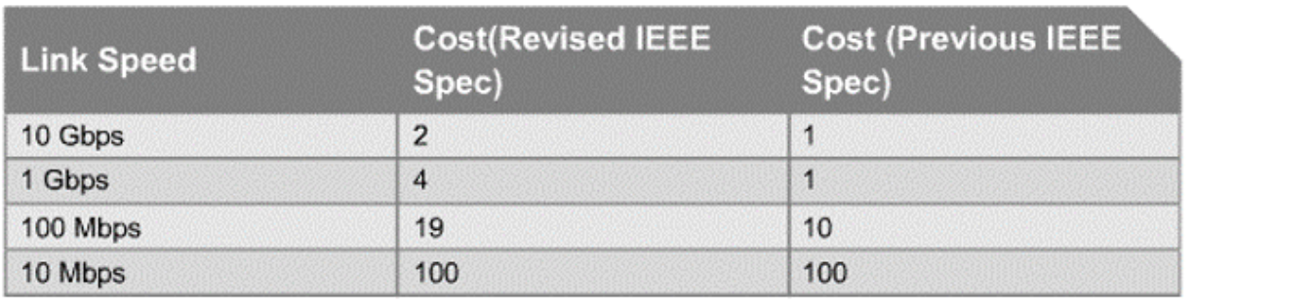

How to tune spanning tree cost

Switch()#Interface fa0/2

Spanning-tree cost 1

Lowest cost – Highest Bandwidth .

1. Lowest Cost

If tie in the cost

1. Upstream Bridge ID

If tie in Upstream Bridge ID

1. Upstream Port number.

If tie in Upstream Port Number

1. Local Port Numbers

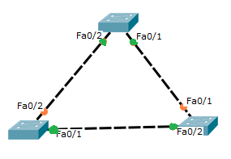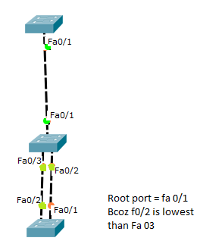

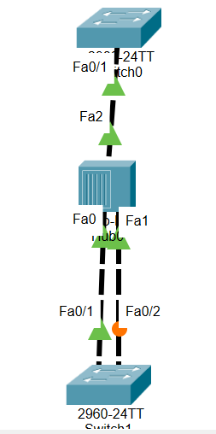

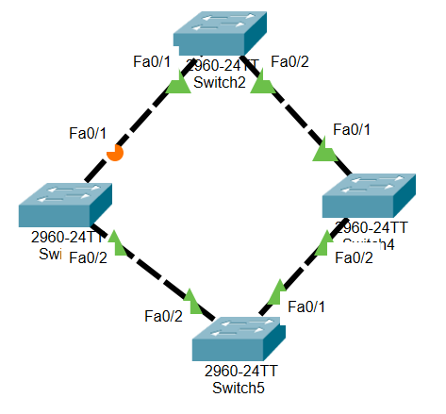

**Port Priority**

You can modify the port priority with the command **spanning-tree [vlan vlan-id] port-priority priority**.

DP and NDP

Least Bridge ID will be DP and the other will be NDP (ALT port)

**STP PORT states**

Disabled

Blocking

Listening

Learning

Forwarding

**STP Port types**

Root Port

DP

NDP

**Bridge Types**

Root bridge

Designated Bridge

**BRIDGE ID SIZE**

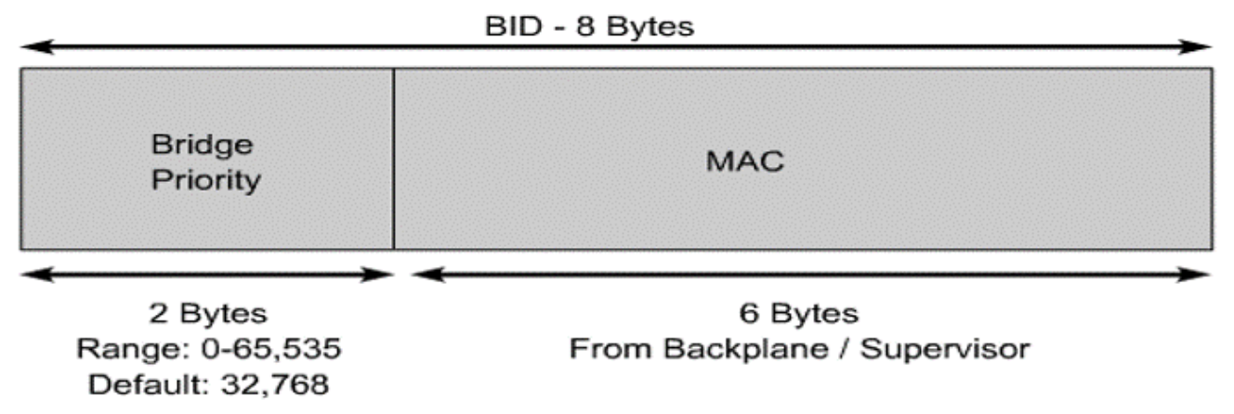

**RSTP – 802.1W**

RSTP is the standard way of speeding STP convergence

Path calculation remains the same as STP.

Inbuilt features of Port fast , Uplink fast and Backbone fast .

RSTP – Combination of Port fast , Uplink fast and Backbone fast .

**Port fast (Cisco Proprietary feature)** –Any device connected to switch it takes 30 seconds , As it goes to LSN and LRN state – Once portfast enabled it will take 1 sec time .

**Uplink fast** – If any direct link goes down , The BLK takes 30 sec time to come up but when Uplink fast is enabled it will take only 1 – 5 second

**Backbone fast** – If any Indirect link goes down– 50 sec --🡪 1 – 5 sec

When RSTP is enabled if any indirect link / Direct Link goes down it will send TCN [ Topology change notification and 1 sec it will come up .

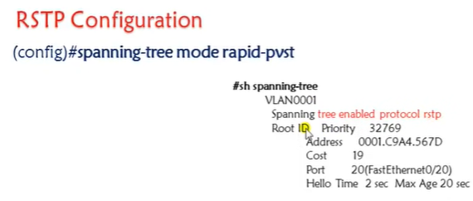

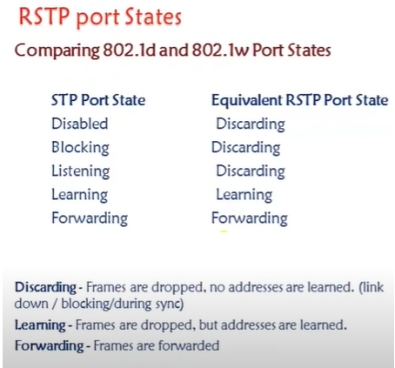

In RSTP – The moment we connect the switches they will send some proposal and agreement statements and accordingly RP and ALT port everything will be selected , Proposal – my BID is so and so I will be the Root Bridge , Agreement – yes I agree to you that your s is lower than mine so I will send agreement that I will reach you through this interface RP.

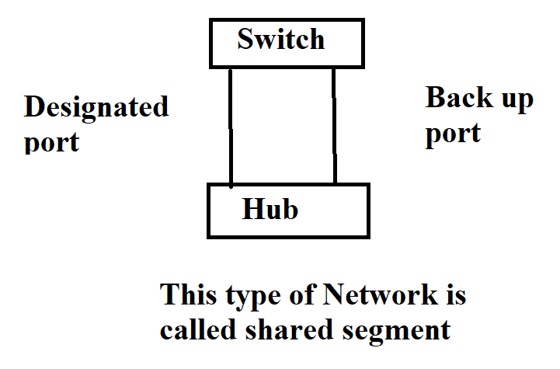

Back up port comes to picture in shared segment topologies where this isn’t available in these days where one link is considered as the DP and the other one as a Back up port.

EDGE port – This concept comes only on RSTP , The end ports where we connect the END DEVICES are called edge ports , Edge ports will never receive the BPDU msgs .

IN STP for every vlan a separate instance of PSTP will be running

IN RSTP for every vlan a separate instance of Rapid PVST will be running

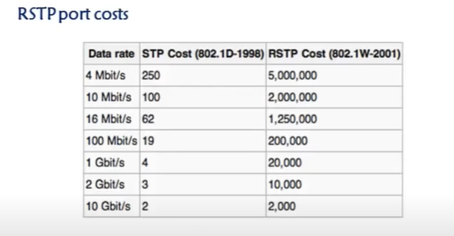

**TOPIC 10 - Securing a switch**

10.1 Configuring Port Security

**Port security** is a layer two traffic control feature on **Cisco** Catalyst switches. It enables an administrator configure individual switch **ports** to allow only a specified number of source MAC addresses ingressing the **port –** Mac flooding .

**NOTE:**

1. Port security is disabled by default. **switchport port-security** command is used to enables it.
2. Port security feature does not work on three types of ports.

Trunk ports

Ether channel ports

Switch port analyzer ports

1. Port security work on host port. In order to configure port security we need to set it as host port. It could be done easily by *switchport mode access* command.

**Switchport port-security Voilation modes**

1.Protect

2.Restrict

3.Shutdown

Switch(config)#interface fastEthernet 0/1

Switch(config-if)#switchport mode access

Switch(config-if)#switchport port-security

Switch(config-if)#switchport port-security ?

mac-address Secure mac address

maximum Max secure addresses

violation Security violation mode

Switch(config-if)#switchport port-security mac-address ?

H.H.H 48 bit mac address

sticky Configure dynamic secure addresses as sticky

Switch(config-if)#switchport port-security maximum ?

<1-132> Maximum addresses

Switch(config-if)#switchport port-security violation ?

protect Security violation protect mode

restrict Security violation restrict mode

shutdown Security violation shutdown mode